SCHOOL OF INFORMATION SCIENCES

(A CONSTITUENT UNIT OF MANIPAL ACADEMY OF HIGHER EDUCATION)



FOOT WEAR SIZE DETECTION USING OPENCV

KEERTHI DL – 181040007

CHANDAN YADAV N – 181040015

COURSE: ME – EWT

GUIDED BY - Mr. Mohan Kumar J

**INDEX**

1. ABSTRACT
2. INTRODUCTION
3. MATERIALS AND METHODS
   1. HARDWARE REQUIREMENTS
   2. RASPBERRY PI SPECIFICATION
   3. SOFTWARE REQUIREMENTS
4. COMPUTER VISION
5. METHOD
   1. SEGMENTATION
   2. THRESHOLDING
   3. CONTOURS
   4. EXTEREME POINTS
   5. EUCLIDEAN DISTANCE
6. BLOCK DIAGRAM
7. FLOWCHART
8. RESULTS
9. CONCLUSION
10. SCOPE OF FUTURE WORK
11. BIBLIOGRAPHY

### CHAPTER-1

## ABSTRACT:

A simple python program to detect the human foot through a medium resolution static image. This algorithm uses an adaptive method to segment the image to identify the particular object. Then contours are drawn around the identified object. Extreme points of the north and south of the contours are marked and distance between them is calculated. This distance would be the height or the length of the human foot. The is length would be converted to centimeters or inches. This length of the foot would be compared in the database. The corresponding details of the footwear size would be obtained as the result.

# INTRODUCTION

Object identification digital images has become one of the most important applications for industries to ease user, save time and to achieve parallelism. This is not a new technique but improvement in object identification is still required in order to achieve the targeted objective more proficiently and precisely.

The main aim of studying computer vision is to simulate the behavior and manner of human eyes directly by using a computer and later on develop a system that reduces human efforts. Computer vision is such kind of research field which tries to perceive and represents the 3D information for world objects. Its main purpose is reconstructing the visual aspects of 3D objects after analyzing the 2D information extracted. Real life 3D objects are represented by 2D images.

This project is based on the object identification in Open CV based on size of object, which is visual based project, the input to project will be a static image. The visual data I.e., static image is processed in the raspberry pi and the corresponding size is detected based on the image from the standard table in database.

The process of object identification analysis is to determine exact size of the object. The common object identification method is the color-based approach, detecting objects based on their color values. The method is used because of its strong adaptability and robustness, however, the detection speed needs to be improved, because it requires testing all possible windows by exhaustive search and has high computational complexity.

OpenCV is an open source computer vision library that is used in real time computer vision. OpenCV was developed by Intel and supported by willow Garage and Itseez. OpenCV is designed and optimized for real time application, it’s cross platform library that runs on Linux, windows and Mac OS. The OpenCV library contains hundreds of functions that cover many areas in computer vision such as robotics, medical image processing, and security.

# Chapter-2

# MATERIALS AND METHODS:

## MATERIALS:

HARDWARE REQUIRMENTS:

Raspberry Pi:

RASPBERRY PI 3 is a development board in PI series. It can be considered as a single board computer that works on LINUX operating system. The board not only has tons of features it also has terrific processing speed making it suitable for advanced applications. The Broadcom BCM2835 SoC used in the first-generation Raspberry Pi includes a 700 MHz, ARM 11 76JZF-S processor, Video core IV Graphical Processing Unit (GPU), and RAM. It has a level 1 (L1) cache of 16 KB and a level 2 (L2) cache of 128 KB. The level 2 cache is used primarily by the GPU. The SoC is stacked underneath the RAM chip, so only its edge is visible. The 1176JZ(F)-S is the same CPU used in the original iPhone, although at a higher clock rate, and mated with a much faster GPU.

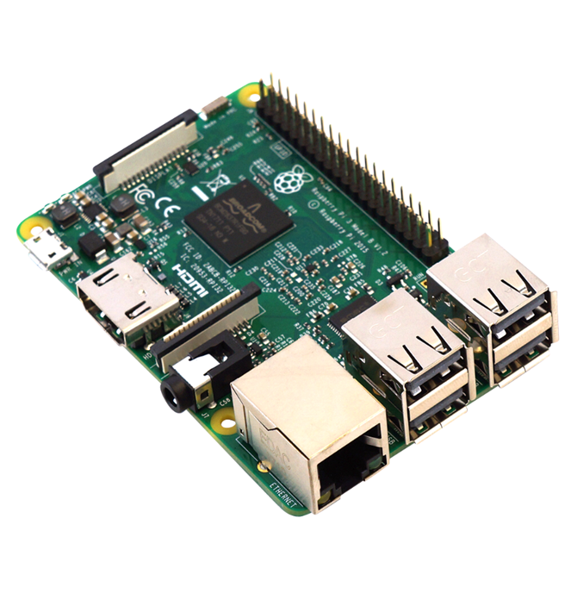

Fig: Raspberry pi3 Model- B

## Raspberry Pi Specifications:

|  |  |
| --- | --- |
| Microprocessor | Broadcom BCM2837 64bit Quad Core Processor |
| Processor operating voltage | 3.3v |
| Raw voltage input | 5V, 2A power source |
| Maximum current through each input-output pin | 16mA |
| Maximum total current drawn from all input-output pin | 54mA |
| Flash Memory | 16Gbytes SSD memory card |
| Internal RAM | 1Gbytes DDR2 |
| Clock Frequency | 1.2GHz |
| GPU | Dual Core Video Core Multimedia Co-Processor. Provides Open GLES 2.0, hardware-accelerated Open VG, and 1080p30 H.264 high- profile decode. |
| Ethernet | 10/100 Ethernet |
| Wireless connectivity | BCM43143 (802.11 b/g/n Wireless LAN and Bluetooth 4.1) |
| Operating Temperature | -40ºC to +85ºC |

# SOFTWARE REQUIREMENT:

Open CV:

OpenCV (Open Source Computer Vision Library) is an open source computer vision and machine learning software library. OpenCV was built to provide a common infrastructure for computer vision applications and to accelerate the use of machine perception in the commercial products. The library has more than 2500 optimized algorithms, which includes a comprehensive set of both classic and state-of-the-art computer vision and machine learning algorithms. These algorithms can be used to detect and recognize faces, identify objects, classify human actions in videos, track camera movements, track moving objects, extract 3D models of objects, produce 3D point clouds from stereo cameras, stitch images together to produce a high resolution image of an entire scene, find similar images from an image database, remove red eyes from images taken using flash, follow eye movements, recognize scenery and establish markers to overlay it with augmented reality

# COMPUTER VISION

Computer vision is an interdisciplinary field that deals with how computer can made to high-level of understanding from the digital images or videos. Computer vision task includes methods for acquiring, processing, analyzing and understanding digital images and extraction of high dimensional data from the real world in order to produce the numeric or symbolic information.

Computer vision is concerned with the theory behind artificial systems that extract information from images. Some of the sub-domains of the computer visions are scene reconstruction, event detection, video tracking, object recognition, 3D pose estimation, learning, indexing, motion estimating, image restoration.

Computer vision is into artificial intelligence, information engineering, solid-state physics, Neurobiology, Signal processing and many more. Computer vision is also related in image processing, image analysis and machine vision that is of determining whether or not the image data contains some specific object, feature, or activity.

* **Object Recognition** is also called as object classification- one or several pre-specified or learned objects or object classes can be recognized, usually together with their 2D positions in the image.
* **Object identification** it is instance of an object recognized. E.g.: identification of specific persons face or finger print
* **Object Detection** in this image data are scanned for the specific condition. E.g. detection of abnormal cells or tissues in medical images etc.

The best algorithms for such task are convolution neural networks. An illustration of of their capabilities is given in the ImageNet large Scale Visual Recognition challenge.

The organization of computer vision system is highly application dependent. Some are stand-alone application which is used to solve specific measurement or detection problem, which also contains sub-system of larger design, for e.g. contains sub system for control of mechanical actuators, planning, information databases man-machine interfaces.

Some important functions found in the computer vision systems are:

* **Image acquisition –** A digital image is produces by one or several image sensors such as light sensitive cameras, tomography devices, ultra-sonic cameras etc. Depending on the type of the sensors resulting image would be in an ordinary 2D image.
* **Pre-Processing –** Before computer vision method is applied to Image in order to extract some information from it like re-sampling, noise reduction, contrast enhancement etc.
* **Feature Extraction –** Features at various level of complexity are extracted from the image such as Lines, edges, ridges, corners, blobs and more complex features like texture, shape or motion.
* **Detection / Segmentation –** In the processing, a decision is made about which image points or regions of the image are relevant for further processing.
* **Decision making –** The final step is the decision required for the application for e.g., pass/fail, match/no-match or should be allowed for human review like medical, military security and recognition applications.

# METHODS:

Image Segmentation –

It is the process of partitioning a digital image into multiple segments which is set of pixels, known as super pixel.

Goal of segmentation is to simplify an image or change the representation of an image so that it would be easier to analyze.

It is typically used to identify the objects and boundaries like lines, curves.

It sorts of assigns a label to every pixel in an image such that pixels with same label share certain characteristics. Some of the application of the Segmentation are:

* Content-based image retrieval
* Medical imagining including volume rendered images from computed tomography and magnetic resonance imagining.
  + Locating tumors and other pathologies
  + Measuring the tissue volumes
  + Surgery planning

Object detection

* + Pedestrian detection
  + Face detection
  + Brake Light detection
  + Locate object in satellite images

## THRESHOLDING -

Simplest method of image segmentation is called the thresholding method. It is based on a clip-level to turn a gray-scale image into binary image. (also called balanced histogram thresholding)

Thresholding a simplest method of image segmentation. From a grayscale image, thresholding can be used to create binary images. In this method each color pixel from an image is replaced with black pixel if the Image intensity is lesser than the constant or to white pixel if the image intensity is greater than constant.

The limit in thresholding is user definable. Larger limit will allow a greater difference between successive threshold values. The advantage of this can be quicker execution with less clear boundary between background and foreground.

Limitations of the thresholding is that will work best when a good background to foreground contrast ratio exists. Meaning the picture must be taken in good lighting conditions with minimal glare.



Fig: Thresholded image

## CONTOURS -

Contours are simplified curve joining all the continuous points having same color or intensity. Contours are useful tool for shape analysis and object detection and recognition.

Contour tracing a technique is applied to digital image in order to extract the boundary of the image. Contour tracing is one of the preprocessing techniques which is applied on the digital image to extract information about their general shape. Once the contour of a given pattern is extracted, it's different characteristics will be examined and used as features which will later on be used in pattern classification. Therefore, correct extraction of the contour will produce more accurate features which will increase the chances of correctly classifying a given pattern.

The amount of computation is greatly reduced when we run **feature extracting algorithms** on the contour instead of on the whole pattern. Since the contour shares a lot of features with the original pattern, the feature extraction process becomes much more efficient when performed on the contour rather on the original pattern.

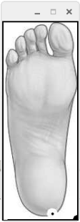

Fig: Contoured image

## EXTREME POINTS -

Extreme points denote the extreme north, south, east and west (x-y) coordinates along the contours, though inherently useful by itself. It's often used as pre-processing step to more advanced computer vision application. By computing the extreme points of the image, we can better approximate the region for advance computer vision techniques.

Steps involved in finding the extreme points first, we load the image from the disk, convert it to grayscale and performs thresholding. In order to detect the outlines, we use function “cv2.findcontours”.

The contour is simply a NumPy array of (x, y)-coordinates. Therefore, we can leverage the NumPy functions to find the extreme coordinates.

Finally, we have our extreme coordinates north, south, east and west. We draw the image for those extreme points/coordinates.

## EUCLIDEAN DISTANCE –

In mathematics, the Euclidean distance is the ordinary straight-line distance between two points in Euclidean space. In cartesian coordinates if p = (p1, p2...) and q= (q1, q2...) are points in Euclidian space then distance from p to q or from q to p is given by the Pythagorean formula as follows

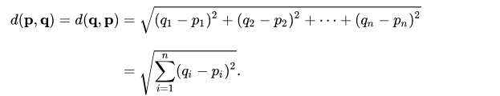

We found the extreme points as per the mentioned in the previous topic. We had to find the distance between those extreme points. Then applying the Euclidian distance formula, we would be able to get the coordinates of the extreme points. Which would be considered as the distance between those extreme points.

# RESULTS –

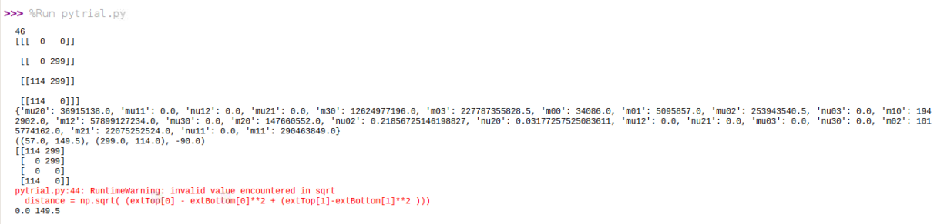

Fig: coordinates of the contour image.

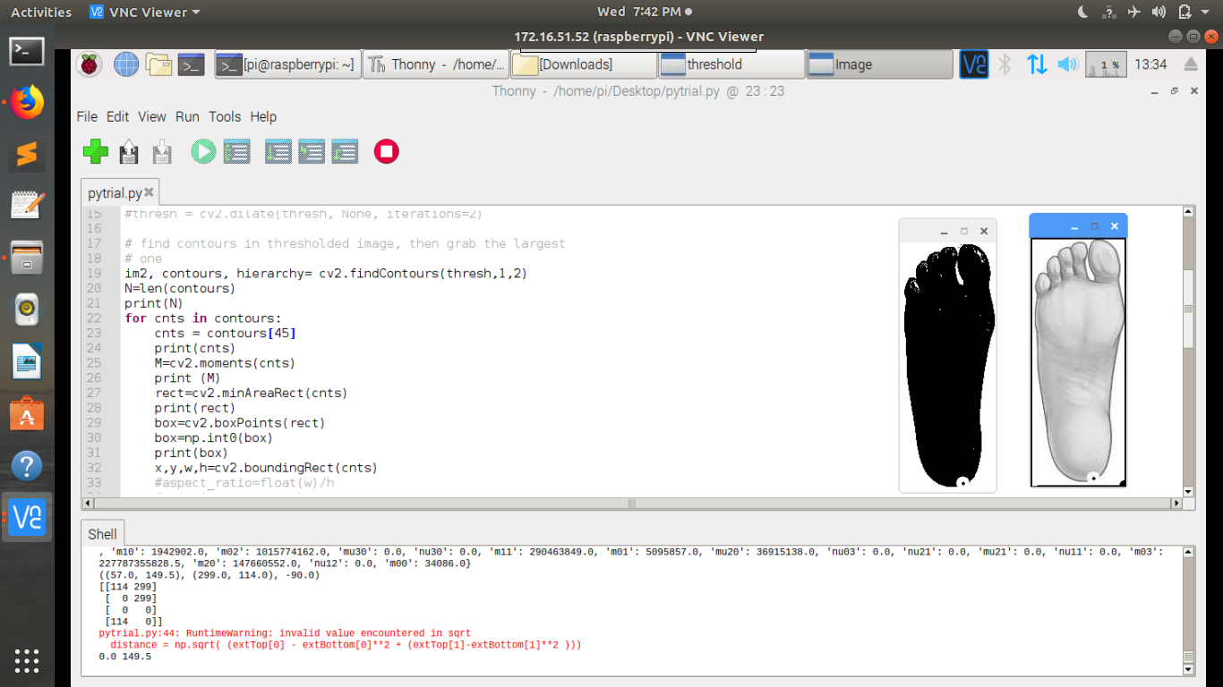

Fig: coordinates of the contour image with its threshold values .

# BLOCK DIAGRAM –

RESULT

INPUT IMAGE

DATABASE

FEATURE

EXTRACTION

PRE

PROCESSING

THRESHOLDING

EUCLIDEAN

DISTANCE

EXTREME POINTS

CONTOURS

# FLOW CHART

EUCLIDEAN DISTANCE

EXTREME POINTS

THRESHOLDING

CONTOURS

IMAGE

IDENTIFICATION

PRE-PROCESSING OF IMAGE

INSERT IMAGE

FALSE

TRUE

END

RESULT

DATABASE

# CONCLUSION

Foot wear size detection was designed and tested using the raspberry pi kit. We used a static image as the input to the system and the system calculates the length of foot using the Euclidean distance formula. The obtained data is stored in the database and corresponding data like standard sizes of 3 different units like UK, US, Euro sized was displayed. The major disadvantage or problem encountering in our project is we are unable to achieve the automation in pre-processing of the image.

# SCOPE OF FUTURE WORK

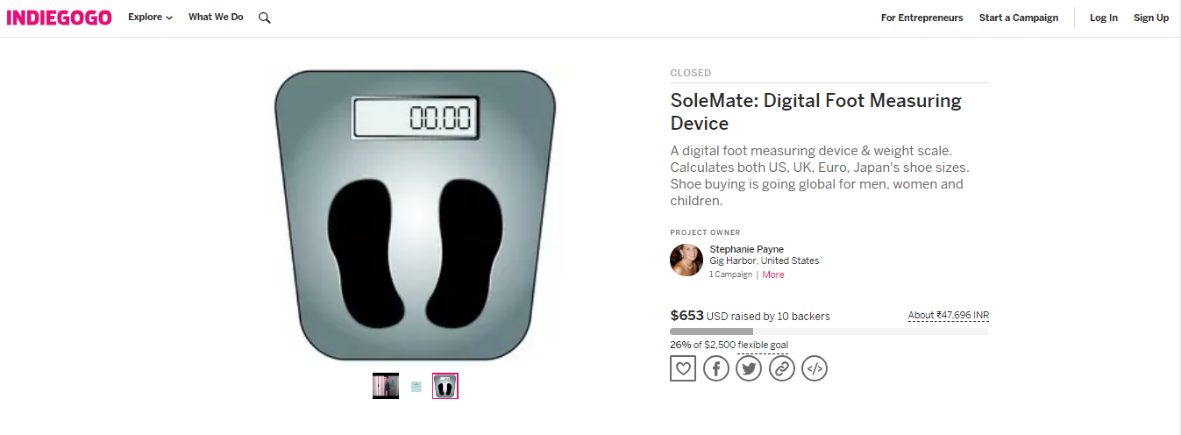

The above image shows a foot measuring instrument from the website INDIEGOGO which costs approx. $653, in Indian rupee it costs approx. 47,696INR, keeping this in mind we were trying to build a prototype which should cost less and can be made accessible to every common man. In future this can be further developed into an application or can be incorporated in any of the E-Commerce application where just clicking picture and uploading should be able display the size of the foot wear.

# BIBLOGRAPHY

1. <http://cds.cern.ch/record/400313/files/p21.pdf>
2. <https://www.pyimagesearch.com/2016/03/28/measuring-size-of-objects-in-an-image-with-opencv/>
3. <https://docs.opencv.org/3.4/dd/d49/tutorial_py_contour_features.html>
4. <https://www.pyimagesearch.com/2016/04/11/finding-extreme-points-in-contours-with-opencv/>
5. <https://docs.opencv.org/3.4.3/d7/d4d/tutorial_py_thresholding.html>